A Comparative Analysis of Stock Performance Across Fossil Fuel, Renewable, and Energy Infrastructure & Storage Firms

Table of Contents
1 Introduction 3
2 Data Collection 3
3 Methodology 4
4 Data Analysis and Results 5
4.1 Descriptive Statistics: 5
5.2 Visualizations: 2
5.3 Financial Metrics 8
5.4 Cointegration Test: 8
5.5 Correlation Matrix: 9
1. Discussion 9
7. Conclusion 10
8. References 10

Introduction
This analysis aims to showcase over the past year the performance of companies dealing in the energy sector, especially looking at the renewable energy sector.
The last year has been marked by significant volatility and structural shifts mainly driven by geopolitical events, and the market saw commodities like oil and natural gas underperforming this year compared to the last 3 years also due to the increasing pressure for the global energy transition toward renewables, and macroeconomic factors like inflation and interest rate changes. This sector overall has been having a slow year which may also signal some deeper instability in the global economy and trade.
By examining key financial indicators such the price over the last year and some financial ratios such as returns on assets (ROA) return on equity (ROE), to understand how much of their performance is coming from debt, earnings per share (EPS), price to earnings ratio (PE), and market cap to understand if there is any correlation regarding the size of the companies and some performance. investors and analysts may gain a comprehensive understanding of the sector's current state and prospects. This knowledge is particularly important given the sector's central role in global economies and its growing importance amidst transitions towards cleaner energy sources.
208

Data Collection
All the Financial information was retrieved from the Bloomberg terminal using the BQL tool for easier date alignment including these companies are listed on different exchanges so they have different holidays and different markets may have been closed. BQL allows also for currencies conversion to the British pound, the 10 companies that have been chosen are:
56
Company name | Bloomberg ticker | Primary exchange | BICS sector 4 level
Siemens AG | SIE GY Equity | Xetra | Diversified Industrials
First Solar Inc. | FSLR US Equity | NASDAQ GS | Renewable Energy Equipment
Eni SpA | ENI IM Equity | Borsa Italiana | Integrated Oils
EnerSys | ENS US Equity | New York | Renewable Energy Equipment
Shell PLC | SHEL LN Equity | London | Integrated Oils
Snam SpA | SRG IM Equity | Borsa Italiana | Gas Utilities
Ultralife Corporation | ULBI US Equity | NASDAQ GM | Renewable Energy Equipment
TotalEnergies SE | TTE FP Equity | EN Paris | Integrated Oils
Ameresco Inc. | AMRC US equity | New York | Renewable Energy Project Dev
NextEra Energy, Inc. | NEE US Equity | New York | Integrated Electric Utilities
Sunex SA | SNX PW Equity | Warsaw | Renewable Energy Equipment

They have been picked to give us a general overview of the whole market not focusing on any specific jurisdiction they vary also in how green their business model is, from companies like First Solar, Sunex and Ameresco being very focused on renewable energy the first 2 dealing in solar while Ameresco focuses on integrated clean energy solutions, including cogeneration and hydroelectric. Then there are companies that are in the middle like Eni and TotalEnergies which still largely deals in hydrocarbons but also has some renewable projects in the works and plans to at some point switch off their involvement in oil and gas even before the 2050 zero carbon target. Then finally there are companies like Shell that has no renewable aims and no intentions to develop them, opting to focus on the exploration, refinement, and sale of hydrocarbons.
Then there are companies dealing in the Infrastructure of energy mainly distribution, and storage, they are also a vital part of the energy sector. There are companies like Snam, which manages Italy's natural gas grid. Other companies such as engineering giant Siemens, which provides broad industrial solutions, and battery specialists EnerSys and Ultralife Corporation.
The fundamental difference lies in their primary energy source and business model: some are cantered on traditional fossil fuels, others on renewable generation, and a third group on the technology and infrastructure required to manage, store, and transmit power in the modern industrial landscape.
236

Methodology
The daily stock returns were calculated using the formula for log returns:
$$R_{t}=\ln\left(\frac{P_{t}}{P_{t-1}}\right) or R_{t}=\ln\left(P_{t}\right)-\ln\left(P_{t-1}\right)$$
Where $P_{t}$ represents the closing price on day $t$, and $P_{t-1}$ represents the closing price on the previous day
Log returns are chosen as they are symmetric. Where a loss is the negative of the gain log return of the same magnitude and they are more preferred due to them more closely approximating the Normal Distribution, which is foundational to many standard statistical and financial models
Before this step we dropped all days where any market was closed, totalling 127 lost days for a total of 238 days where we have data, opting to reduce the number of days is the simplest way to make sure that all the data is aligned and there are no empty cells.
133

Data Analysis and Results

Descriptive Statistics:
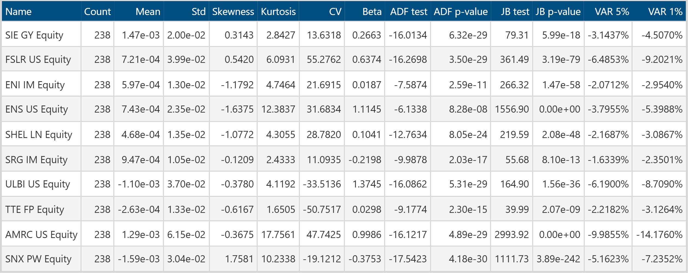
Table 1: Descriptive Statistics of Selected Companies in the Energy Sector
This table showcases much of the descriptive statistics analysis plus some more interesting tests, overall, the returns were very low this year, with three companies going in the negatives, most of the companies, one note before the comments is that all these results are flawed as they only include data for one year, with more data you would get a better understanding of the underlying dynamics of these companies outside of this tumultuous year.
The daily average returns were low this year, with three companies going in the negatives, possibly implying some deeper issues in the economy especially when it comes to trade.
The standard deviation varied significantly, with the least risky stock (Snam) having a standard deviation of 1.05% and the most volatile (Ameresco) reaching 6.15%. due to cautious earnings outlook and project execution concerns in April, followed by an aggressive rebound on strong contract conversion and market optimism.
Skewness is highly varied, ranging from strongly negative (potential for large losses) to strongly positive (potential for large gains).
Kurtosis: Nearly all stocks show leptokurtosis (kurtosis above 3), with Ameresco (17.76) and EnerSys (12.38) showing an extremely high probability of extreme returns (“heavy tails")
CV: The Coefficient of Variation, a measure of risk-per-unit-of-return, what does it mean for risk adverse investors?
Beta $\left(β\right)$: Systematic risk compared to the reference index of the S&P 500 as it is a good proxy of the overall economy, done via regression of the stock return onto the S&P 500,
A company such as ULBI and ENS indicated that their beta was larger than 1, so this indicates greater volatility than the index. SNX and SRG indicated a beta less than 0, which is a negative position with respect to the index meaning that on average when the index gains the company loses and vice versa.
Other companies like SIE and AMRC showed a beta less than 1, which indicates a greater stability of the firm under change in market conditions, in exchange for lower returns when the index spikes.
ADF test: The Augmented Dickey-Fuller (ADF test statistics) are all highly negative (maximum value being −6.13), confirming the returns series are stationary and appropriate for time-series modelling. The core purpose of the ADF test is to check for the presence of a unit root in a time series, with the null hypothesis being that a unit root is present,
ADF p-value: Every asset has an ADF p-value well below any significance level, unequivocally rejecting the null hypothesis of a unit root. This test follows a specific, non-standard probability distribution known as the tau $τ$ distribution.
JB test: The Jarque-Bera test statistics are uniformly high (the lowest value being 39.99), indicating a significant and widespread deviation from a normal distribution across all assets.
JB p-value: All JB p-values are practically zero, definitively rejecting the null hypothesis that the daily log returns are normally distributed. This is a hard assumption in much of financial modelling, and this coupled with the few datapoints makes this very understandable.
The Jarque-Bera test statistics asymptotically follows a Chi-squared ($χ^{2}$)
VAR 5%: The 5% VaR highlights that the maximum expected loss in a single day, 5% of the time, ranges from 1.63% (Snam) to a significant 9.99% (Ameresco), this has been calculated with the flawed approach of the gaussian assumption, even after we denoted that none of these stocks returns follow a normal distribution. The VAR at 1% reinforces the potential for substantial downside risk in the most volatile stocks.
578 total 1211

Visualizations

Price visualizations
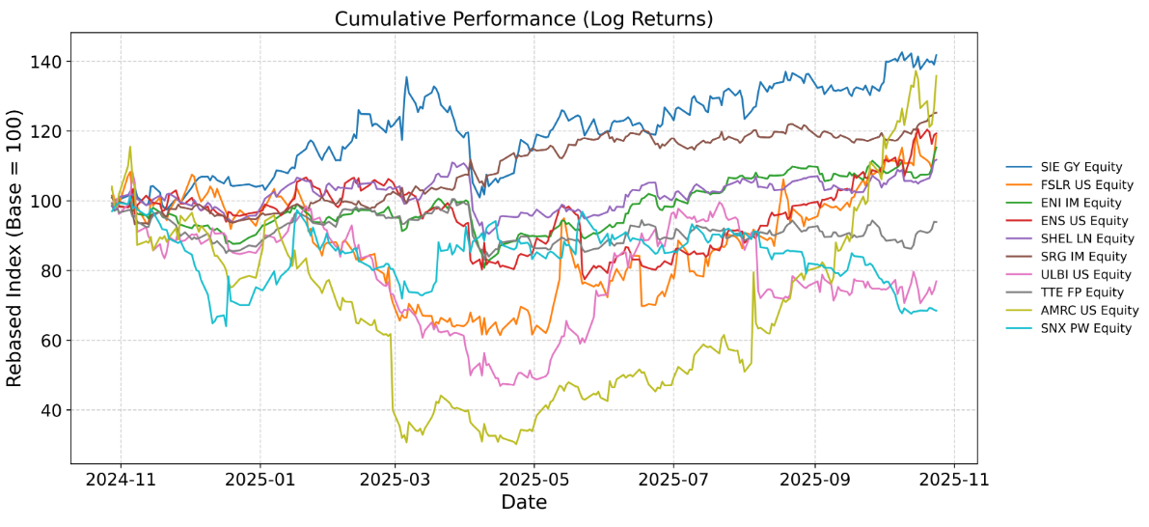
Figure 1: Cumulative Performance of Selected Companies (Log Returns) with Rebased Index (Base = 100)
In Figure 1, the cumulative performance of selected companies from late 2024 to late 2025 shows various growth trends. SIE and FSLR tracked strong upward trends, whereas SNX PW Equity shows a steep decline. AMRC had a dip and recovered due to some future financial outlook and project cost issues, despite good earnings.
53
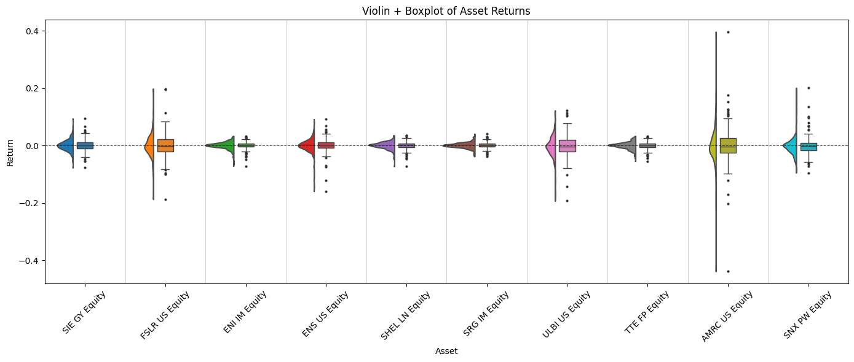
Figure 2: Violin and Boxplot of Asset Returns for Selected Companies in the Banking and Finance Sector
Figure 2 presents a violin and boxplot of returns on assets for banking and finance companies and demonstrates areas of greater density and wider distributions. Firms such as First Solar and Amersco indicate higher risks while Snam and TotalEnergies indicate more stable returns.
43

Correlation matrix
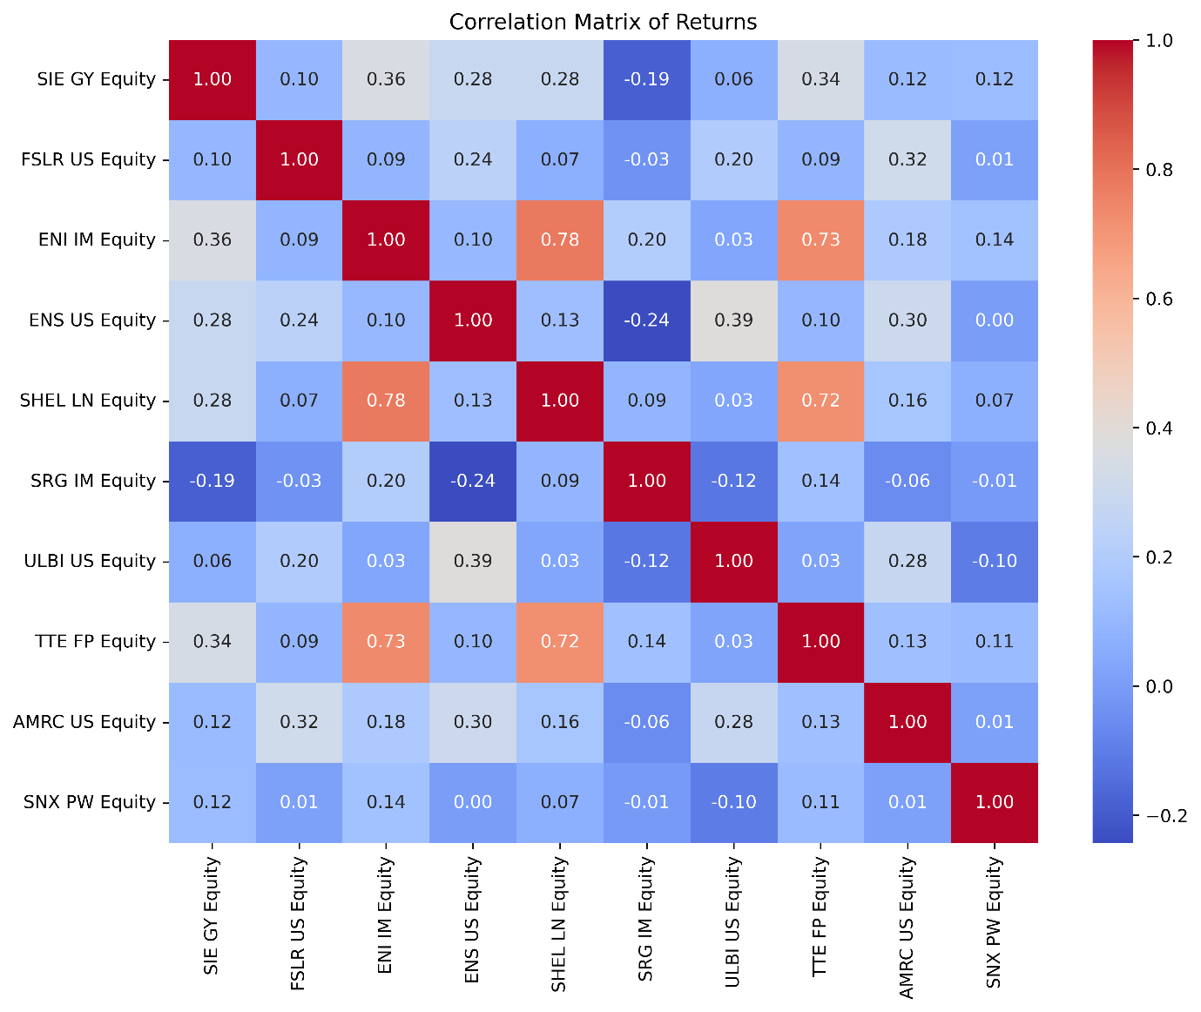
Figure 3 presents a correlation matrix of returns for various companies in the banking and finance sector

Here with this correlation plot we can clearly see the reliance that ENI Shell and TotalEnergies still have with each other, mainly due to their connection to the price of oil, while the rest don’t really show strong correlations due to their businesses being overall diversified although the assumption is that this is due to the few datapoints and possibly they could be correlated with another green ETF or index like Invesco WilderHill Clean Energy ETF
76
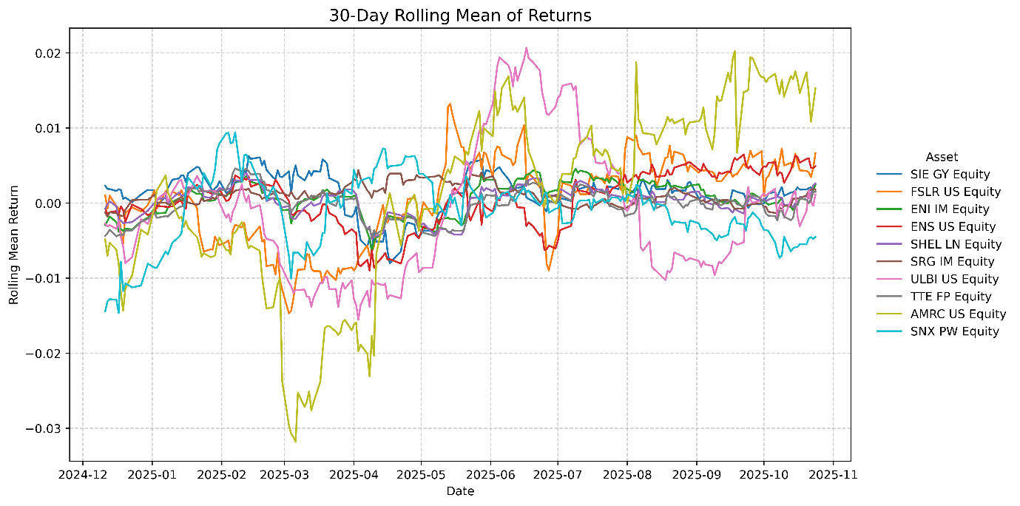Figure 5: 30-Day Rolling Mean of Returns for Selected Companies
The 30-day rolling mean of returns and shows very few outliers with all companies going together aside from Amersco for the aforementioned reasons.
23
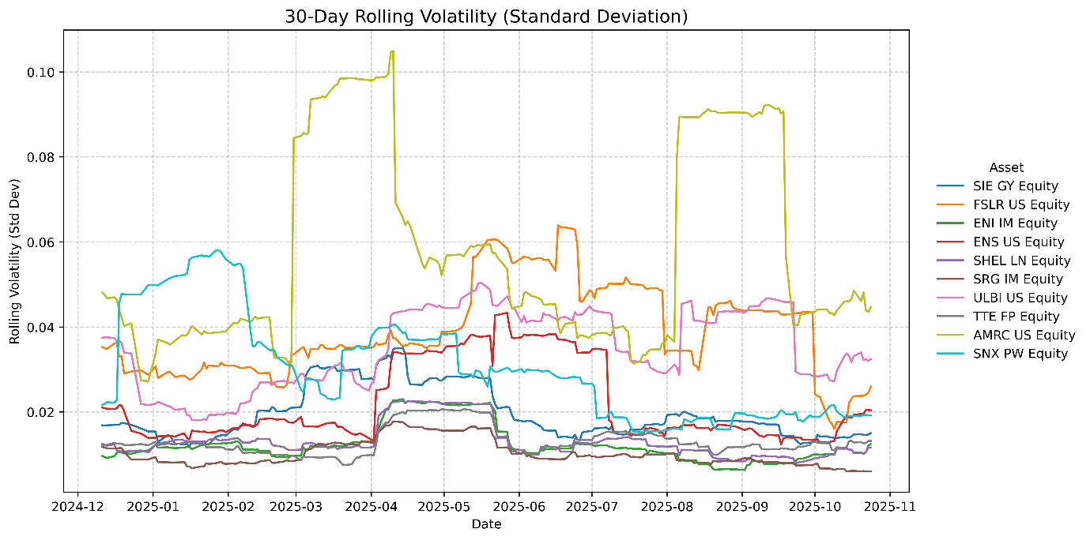
Figure 6: 30-Day Rolling Volatility (Standard Deviation) for Selected Companies
The rolling volatility shows an indication of where the prices changed dramatically and its easy to see that some companies like have low volatility and Amersco spikes up when the last 2 earnings call got announced.
36
Total 1,452
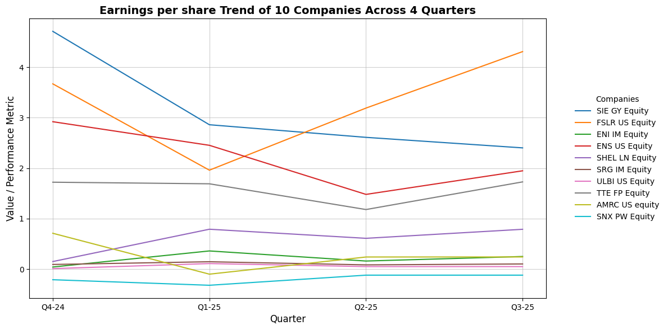
Figure 7: Earnings per Share Trend of 10 Companies Across 4 Quarters
The trends in EPS across four quarters are shown in Figure 7 for ten companies. SIE GY Equity and FSLR US Equity show significant growth in EPS which suggests improved profitability, while TTE FP Equity and AMRC US Equity show static or decreased trends that suggest differing financial performance.
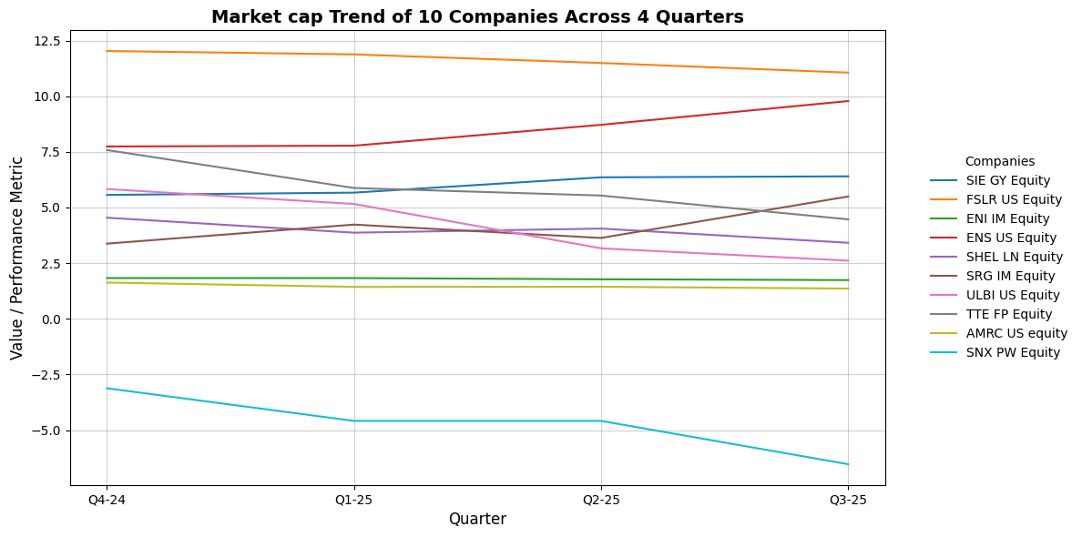
Figure 8: Market Cap Trend of 10 Companies Across 4 Quarters
The market capitalization trend of 10 companies is shown in Figure 8 over four quarters and indicates strong upward trends for FSLR US Equity and SIE GY Equity and an upward trend in market capitalization, while SNX PW Equity and AMRC US Equity show declines in market capitalization and indicate poor performance.
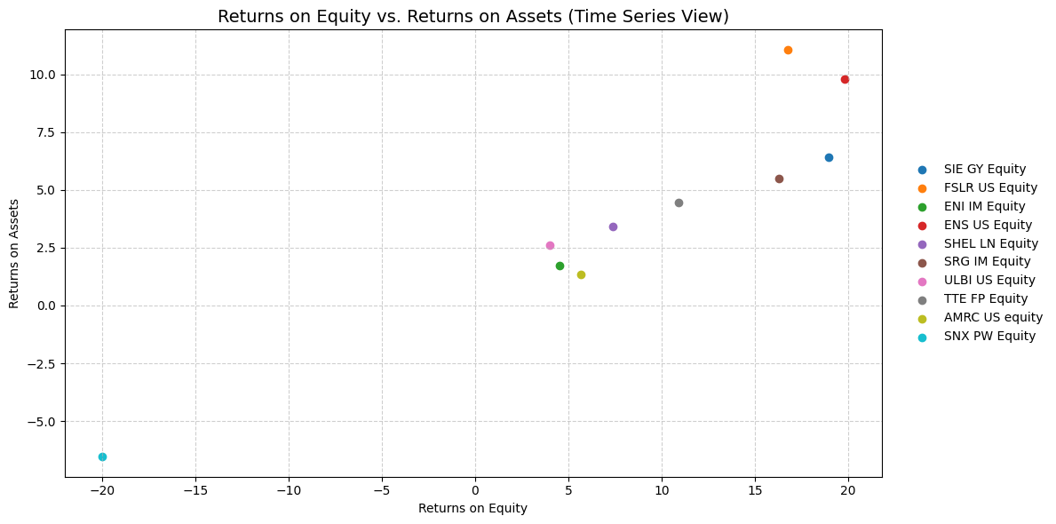
Figure 9: Returns on Equity vs. Returns on Assets (Time Series View) for Selected Companies
Figure 9 Returns on Equity (ROE) against Returns on Assets (ROA) across the selected companies, demonstrating how the companies are managed and performing profitably. Positive returns can be seen from SIE GY Equity and FSLR US Equity, which have materially strong positive returns. In contrast, SNX PW Equity and AMRC US Equity have negative values, indicating poor financial performance.
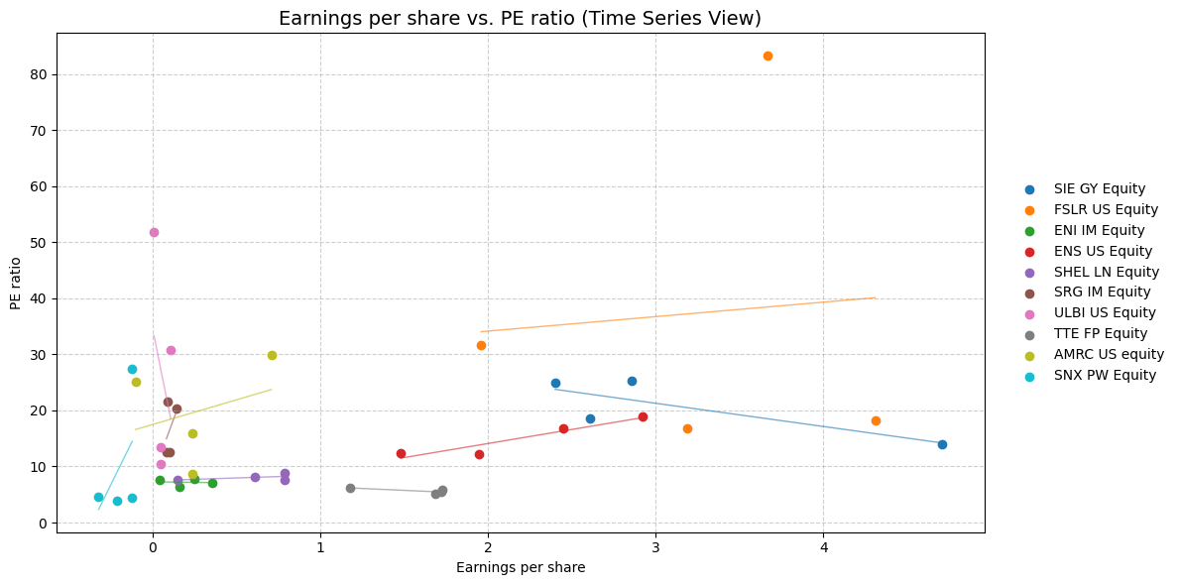
Figure 10: Earnings per Share vs. PE Ratio (Time Series View) for Selected Companies
Figure 10 show relationship between Earnings per Share (EPS) and Price-to-Earnings (PE) ratios of selected banking and finance companies. Firms such as FSLR US Equity, and SIE GY Equity show a positive relation between EPS and PE ratio, meaning higher price-to-earnings ratios. On the other hand, AMRC US Equity and SNX PW Equity show low EPS at low to high PE ratios which demonstrate differing profitabilities and market valuations.
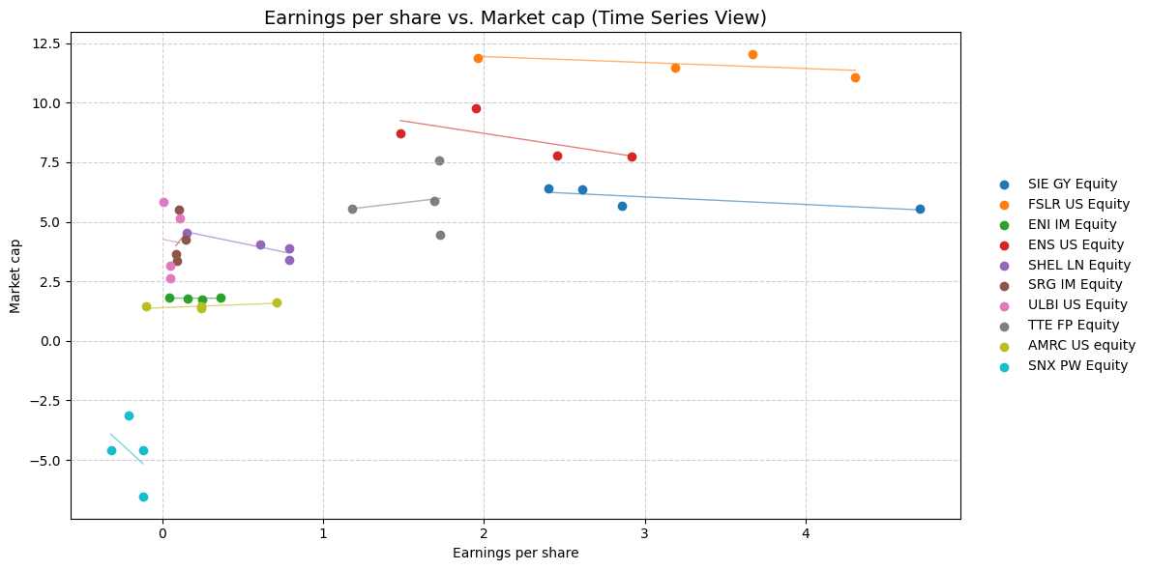Figure 11: Earnings per Share vs. Market Cap (Time Series View) for Selected Companies
In Figure 11, the relationship between Earnings per Share (EPS) and Market Capitalization is presented in the Banking and Finance sector. For FSLR US Equity and SIE GY Equity, there is a positive trend, as the EPS value increases. SNX PW Equity and AMRC US Equity possess lower market caps than implied by their EPS metric, indicating weak investor sentiment towards these companies.

5.3 Financial Metrics
Table 3: Financial Metrics for Selected Companies (Q3 2025)
Company | P/E Ratio (PE) | Market Capitalization (MKT) | Earnings per Share (EPS) | Return on Assets (ROA) | Return on Equity (ROE) | ESG Score
SIE GY Equity | 24.94 | 6.4 | 2.4 | 6.4 | 18.95 | 6.65
FSLR US Equity | 18.17 | 11.06 | 4.31 | 11.06 | 16.77 | 5.54
ENI IM Equity | 7.82 | 1.74 | 0.25 | 1.74 | 4.55 | 7.08
ENS US Equity | 12.15 | 9.78 | 1.95 | 9.78 | 19.82 | 3.46
SHEL LN Equity | 8.89 | 3.42 | 0.79 | 3.42 | 7.4 | 7.25
SRG IM Equity | 12.5 | 5.5 | 0.1 | 5.5 | 16.28 | 4.81
ULBI US Equity | 13.47 | 2.61 | 0.05 | 2.61 | 3.99 | 2.19
TTE FP Equity | 5.76 | 4.47 | 1.73 | 4.47 | 10.93 | 6.92
AMRC US Equity | 15.9 | 1.36 | 0.24 | 1.36 | 5.66 | 1.66
SNX PW Equity | 27.36 | -6.53 | -0.12 | -6.53 | -20.01 | 1.88
Table 3 highlights significant differences in financial metrics for various companies in Q3 2025, notably the P/E Values with SNX PW Equity at 27.36 and TTE FP Equity at 5.76. FSLR US Equity leads in Market Capitalization at 11.06, while SNX PW Equity shows a negative valuation. Additionally, ROE varies among companies, reflecting different performance standards and shareholder return efficiencies.
- Discussion
The analysis of the data shows a range of risk and performance levels among the firms. For risk, AMRC US Equity has the highest with a standard deviation equal to 6.15E-02 while TTE FP equity, showing lower risk and safer returns, has the lowest standard deviation equal to 1.33E-02. AMRC US Equity and ENS US Equity are firms that have high market betas, which implies market sensitivities (risk) and less stable returns, while SNX PW Equity and SRG IM equity is lower beta firms demonstrating strong resistance to changes in the market. Investors with conservative preferences will like TTE FP EQUITY for its low volatility while risk-seeking investors may choose a higher risk path with AMRC US Equity or ULBI US Equity for potentially higher returns in good markets but higher and substantial downside risk in bad markets, as demonstrated by firms such as FSLR US Equities and ENS US Equity.
Firms such as FSLR US Equity and ENS US Equity have had strong performance and profitability as represented by high ROA and ROE. SNX PW Equity is contrary to these firms, has a high P/E ratio at 27.36 (suggestion valuation of firm) negative actual returns, and low ESG scores at 1.88 demonstrating poor financial performance. Higher ESG-rated firms like SIE GY Equity and TTE FP Equity emphasize sustainability and demonstrate superior performance.

7. Conclusion
In banking and finance performance evaluations, several aspects of risk and return are considerably different among firms. High-performing firms such as FSLR US Equity and ENS US Equity show relatively high returns with high risk/volatility, while TTE FP Equity and SNX PW Equity provide more moderate returns with lower risk/volatility, inviting risk-averse investors to engage. Furthermore, firms with ESG ratings above the sector average, such as SIE GY Equity and TTE FP Equity, show a positive association with financial performance and developing sustainability initiatives. These observations provide valuable metrics for investors to assess performance, risk, returns, and overall portfolio diversification.

8. References
Allen, F., Brealey, R. A., & Myers, S. C. (2011). Principles of corporate finance (p. 1043). New York: McGraw-Hill/Irwin. https://epage.pub/doc/principles-of-corporate-finance-10th-edition-y4gnrjxon1
Brooks, C. (2014). Introductory econometrics for finance. Cambridge university press. https://books.google.com/books?hl=en&lr=&id=qTE4AwAAQBAJ&oi=fnd&pg=PR12&dq=Brooks,+C.+(2019).+Introductory+Econometrics+for+Finance+(5th+ed.).+Cambridge+University+Press.&ots=C1scp613GH&sig=Hg4EWXDmjMouxUCRIZTDjRpWaRM
Deepakshi, M., Kamboj, M. G., Kaur, M. T., Garima, M., & Kaur, N. Studying the Share Price Determinants with Regard to EPS, Cash Flows, Market Capitalization, PE Ratio and ROCE for Seeing their Impact on Market Price Per Share for last 10 Years Ending March 31st ie (2015-2024). https://ijnrefm.com/wp-content/uploads/2025/04/ijnrefm-vol-3-issue2-144.pdf
Engle, R. F., & Granger, C. W. (1987). Co-integration and error correction: representation, estimation, and testing. Econometrica: journal of the Econometric Society, 251-276. https://www.jstor.org/stable/1913236
Fama, E. F., & French, K. R. (1993). Common risk factors in the returns on stocks and bonds. Journal of financial economics, 33(1), 3-56. https://www.sciencedirect.com/science/article/pii/0304405X93900235
Goldstein, I. (2023). Information in financial markets and its real effects. Review of Finance, 27(1), 1-32. https://academic.oup.com/rof/article-abstract/27/1/1/6659542
Gomez, C. (2008). Financial markets, institutions, and financial services. PHI Learning Pvt. Ltd. https://books.google.com/books?hl=en&lr=&id=qux6w5n366cC&oi=fnd&pg=PP1&dq=+Financial+Institutions+and+Markets+(12th+ed.).+Cengage+Learning.&ots=2B_eBTklGt&sig=PLomhkJE0Y8i0Wtb6QdeKvxcBJ0

05/11/2025 15:23

TODO
✅Fix graphs
Numbers in captions
✅Fix GT black and maybe no striping
Read and fix punctuation :p
✅Better spacing so maybe we don’t have the desc table in the other page
✅Remove sections to have consistent page numbers
✅Possibly rethink that we do all the prices stuff and then all the Ratios stuff

